Challenges in Computer Vision
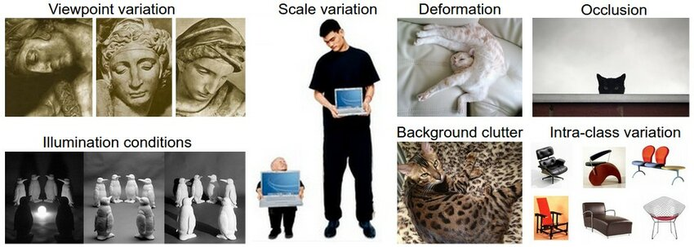
1)Viewpoint variation:-
Reference:- https://www.researchgate.net/publication/358087877_Online_clustering-based_multi-camera_vehicle_tracking_in_scenarios_with_overlapping_FOVs
Viewpoint variation in images refers to changes in the angle or perspective from which an object or scene is viewed
Handling viewpoint variation in action recognition involves dealing with changes in the perspective from which actions are observed. Here are some techniques simplified:
- Data Augmentation: By rotating, flipping, or scaling images, we can create variations in viewpoint, helping the model recognize actions from different angles.
- 3D Models: Instead of relying solely on 2D images, using 3D models allows the model to understand actions from different viewpoints, making recognition more robust.
- Viewpoint-Invariant Features: Focus on extracting features from actions that are less affected by changes in viewpoint, such as motion trajectories or body joint movements.
- Temporal Alignment: Aligning action sequences in time helps the model compare actions across different viewpoints, making recognition more consistent.
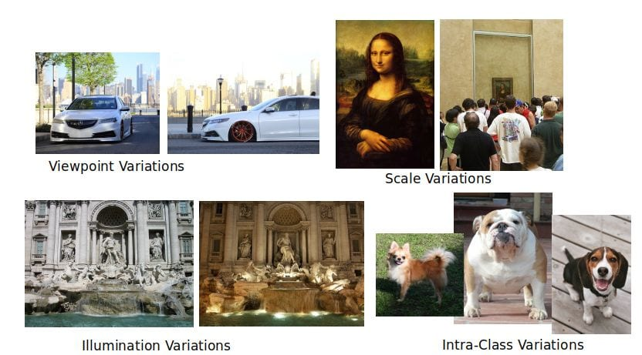
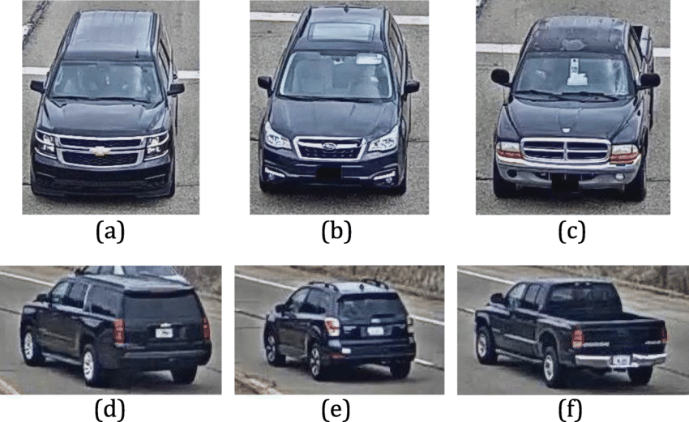
- Domain Adaptation: Train the model on data from various viewpoints to make it more adaptable to different perspectives encountered during inference
2)Illumination Condition:-
Reference:- https://www.qualitymag.com/articles/93742-the-importance-of-consistent-illumination-in-machine-vision
Illumination condition refers to changes in the lighting environment, which can affect the appearance of objects or scenes in images.
- Data Augmentation: Adjust brightness, contrast, or add shadows in training images to simulate different lighting situations.
- HDR Imaging: Capture a wider range of light levels to show objects more accurately in varying lighting conditions.
- Invariant Features: Focus on details in images that don't change much with different lighting, like texture patterns or basic shapes.
- White Balance: Make sure colors in images look consistent by adjusting color temperature and white balance.
- Domain Adaptation: Train the model on images taken in different lighting conditions to help it recognize objects in various environments.
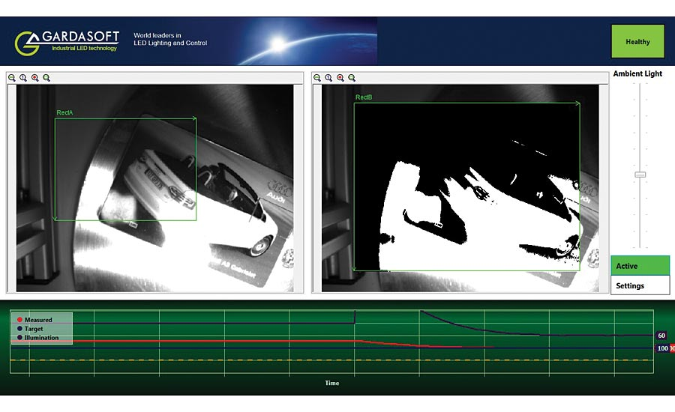
By doing these things, we help the model handle changes in lighting better, so it can recognize objects more reliably.

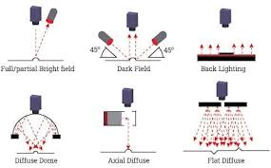

3)Scale Variation:-
Reference:- https://link.springer.com/article/10.1007/s10489-022-03549-6
Scale variation refers to changes in the size of objects or scenes depicted in images. This variation can pose a challenge for object recognition systems, as objects may appear larger or smaller depending on factors such as distance from the camera or changes in zoom level.
- Data Augmentation: Resize images to simulate different object sizes during training. This helps the model learn to recognize objects at various scales.
- Pyramid Representations: Use image pyramid representations, where images are scaled to multiple resolutions. This allows the model to analyze objects at different scales within the same image.
- Feature Pyramid Networks: Employ networks that extract features at multiple scales within the same image. This helps in capturing information from objects at different sizes.
- Scale-Invariant Features: Extract features that are less affected by changes in scale, such as corner points or scale-invariant descriptors like SIFT or SURF.
- Multi-Scale Fusion: Combine information from multiple scales during feature extraction or classification to improve the model's ability to handle scale variation.
By incorporating these techniques, we enable the model to recognize objects accurately across a wide range of sizes, making it more robust to scale variation

4)Deformation:-
Deformation in images refers to the distortion or alteration of objects or shapes due to factors like perspective, occlusion, or physical manipulation.
Here's how to handle deformation:
- Data Augmentation: Introduce deformations in training images by applying transformations like rotation, translation, scaling, or shearing. This helps the model learn to recognize objects in various deformed states.
- Elastic Distortion: Apply elastic deformations to images, simulating the natural flexibility of objects. This technique introduces random distortions that mimic real-world deformations.
- Spatial Transformer Networks (STNs): Use STNs to learn spatial transformations directly from the data. These networks can dynamically adjust the spatial configuration of features, helping the model handle deformations more effectively.
- Deformation-Invariant Features: Extract features that are less sensitive to deformations, such as local binary patterns (LBPs) or histogram of oriented gradients (HOG). These features focus on local texture or gradient information, which remains relatively stable under deformation.
- Deformation Modeling: Incorporate models that explicitly capture and compensate for deformations in the image. This can involve using deformable part-based models or deformable convolutional networks to adaptively adjust to the shape and structure of objects.
By integrating these techniques, object recognition systems can better handle deformations and variations in object shape, leading to more accurate and robust performance across different scenarios.

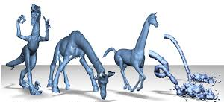

5)Occulusion:-
Reference:- https://blog.roboflow.com/intro-to-computer-vision/
Occlusion is handled in few ways – occulusion augmentation like random erase ,cutout,hide and seek,grid mask,mosaic,cutmix
They are:-
• Random Erasing: Cover parts of an image randomly with blobs or patches to help models focus on other areas.
• Cutout: Cut out a piece of the image and fill it with a solid color to train the model to recognize objects even when parts are missing.
• Hide and Seek: Hide parts of the image and ask the model to find them, encouraging it to pay attention to different areas.
• Grid Mask: Overlay a grid on the image and mask out certain parts to help the model focus on specific areas while ignoring others.
• Mosaic: Mix pieces of different images to create a new one, training the model to recognize objects in various contexts.
• CutMix: Similar to Cutout, but replace the cut part with a piece from another image, helping the model learn from multiple images simultaneously
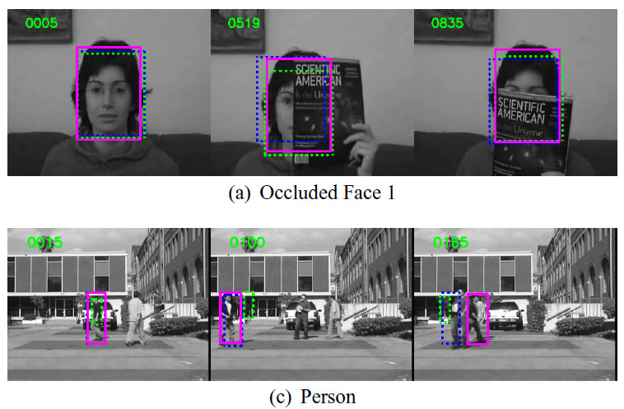

6)Background Clutter:-
Reference:- https://www.semanticscholar.org/paper/Cluttered-Background-Removal-in-Static-Images-with-Nagarajan-Balasubramanie/c36d39a8505744dc7d3a1e20215e0d3c54c3e0b1
Background clutter refers to the presence of irrelevant or distracting elements in the background of an image, which can hinder object recognition
Handling background clutter is crucial for accurate object recognition, especially in complex scenes where objects may be surrounded by various irrelevant elements. Here's how to address background clutter:
- Background Subtraction: Use background subtraction techniques to isolate foreground objects from cluttered backgrounds. This helps in focusing the model's attention on relevant objects.
- Semantic Segmentation: Apply semantic segmentation to classify each pixel in the image as belonging to the foreground object or background clutter. This allows the model to ignore cluttered regions during object recognition.
- Attention Mechanisms: Incorporate attention mechanisms into the model architecture to dynamically focus on informative regions of the image while suppressing background clutter. This helps in improving the model's ability to attend to relevant features.
- Contextual Information: Utilize contextual information from surrounding pixels or regions to distinguish between objects and clutter. This can be achieved through methods like contextual reasoning or scene understanding.
- Data Augmentation: Introduce variations in background clutter during training by adding diverse backgrounds or overlaying cluttered scenes onto object images. This helps the model learn to recognize objects amidst cluttered backgrounds.
- Adversarial Training: Train the model against adversarial examples that mimic background clutter to improve its robustness to cluttered environments.
- Transfer Learning: Fine-tune pre-trained models on datasets containing background clutter to adapt them to cluttered scenes. This helps in leveraging existing knowledge to improve performance in cluttered environments.
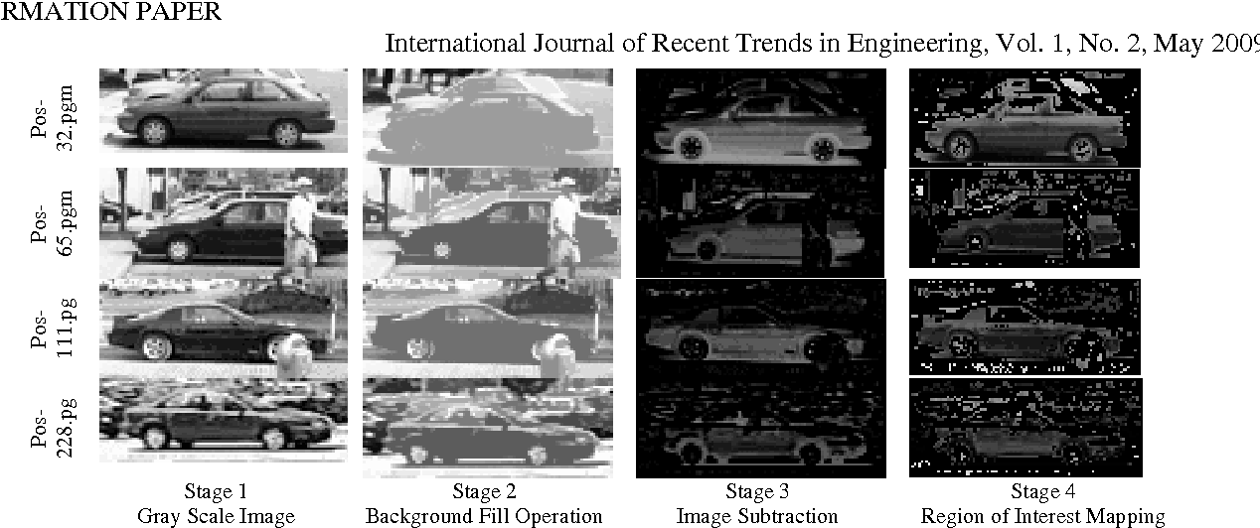
By implementing these strategies, object recognition systems can effectively mitigate the impact of background clutter, leading to more accurate and reliable recognition results, even in complex scenes.
7) Intra-class variation:-
Reference:- https://hackernoon.com/mit-6-s094-deep-learning-for-self-driving-cars-2018-lecture-4-notes-computer-vision-f591f14b3b99
Intra-class variation refers to the differences or diversity observed within the same category or class of objects. For example, within the category of "cats," there can be variations in terms of color, size, breed, fur patterns, and poses. Handling intra-class variation is crucial for object recognition systems to accurately identify objects despite these variations. It involves ensuring that the model can generalize well and recognize objects regardless of differences within the same class.
Dealing with intra-class variation means handling differences within the same object category, like changes in appearance, pose, or lighting. Here's how to manage it:
- Data Variety: Use diverse images of the same object category during training. This helps the model recognize objects even if they look different.
- Fine Details: Teach the model to notice subtle differences between similar objects within a category. This helps in recognizing specific types or variations of objects.
- Robust Features: Train the model to focus on features that stay the same despite changes, like overall shape or texture. This helps it identify objects regardless of small differences.
- Combine Knowledge: Use multiple models or techniques together to cover a wider range of variations within the same category. This improves the model's ability to recognize diverse objects.
- Learn from Examples: Train the model on examples of objects in different poses, lighting conditions, or backgrounds. This helps it understand variations it might encounter in real-world situations.
By using these methods, we can help the model recognize objects accurately, even when they look a bit different from each other.
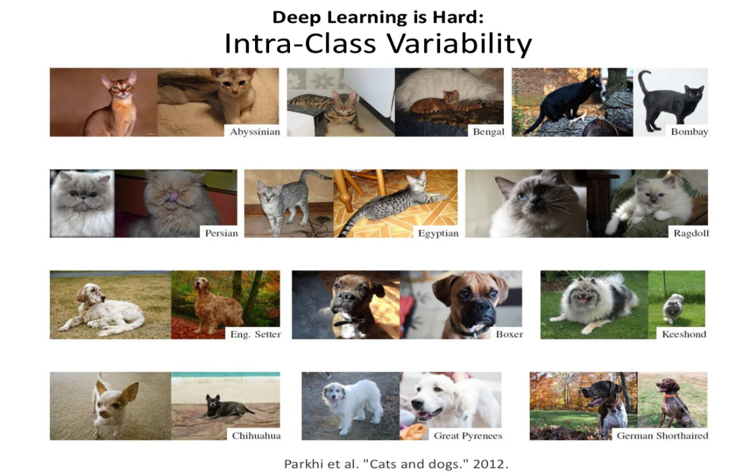

Refference:- https://www.geeksforgeeks.org/count-number-of-object-using-python-opencv/

Using OpenCV in python
Blurring images helps to reduce noise, making the images smoother and more visually appealing. Noise appears as random variations in brightness or color, often caused by low light or high ISO settings in cameras.
There are several ways to blur images, with some common methods being:
- Gaussian Blur: Smooths the image using a Gaussian function.
- Average Blur: Averages the pixel values in a neighborhood.
- Median Blur: Uses the median value of the pixel neighborhood, effective for reducing certain types of noise.
Edge detection is like outlining the boundaries of objects in an image. It helps computers understand where one object ends and another begins. One popular method for edge detection is Canny edge detection. It works by finding areas of high contrast in the image, like where there's a big change in brightness or color. Then, it connects these areas to form edges. This makes it easier for computers to recognize shapes and objects in pictures.
CV_BLUR,CV_BLUR_NO_SCALE,CV_MEDIAN,CV_GAUSIAN and CV_BILATERAL
Connecting edges in image processing means linking nearby edge pixels to form continuous lines or curves, helping computers recognize shapes in images. It's like connecting dots to form a picture. First, we find edges using methods like Canny edge detection, marking where objects start and end. Then, we connect these marked points to create smooth outlines of objects, ensuring important details aren't missed. By connecting edges, computers can better understand images, identifying objects or patterns. It's like completing a puzzle, where each edge pixel is a piece revealing the bigger picture.
Drawing boundaries around objects using polygons is a smart idea, but it can take a while. This method involves outlining objects using shapes like triangles or rectangles. Each shape is drawn by connecting the corners. While it's accurate, it does take time because we have to carefully find the edges of objects and decide on their shapes. Even though it's slow, using polygons helps us clearly see and understand objects in images, which is important for things like recognizing what's in a picture.

Image Annotation:-
Reference:- https://docs.roboflow.com/annotate/annotation-tools
Annotation methods play a crucial role in preparing training data for machine learning models. Here are the annotation methods mentioned in the provided text:
- Drawing Bounding Boxes and Polygons Manually: This method involves manually drawing bounding boxes or polygons around objects of interest in images. Bounding boxes are easier and quicker to draw but may be less precise compared to polygons.
- Using Label Assist: Label Assist is a tool that utilizes model checkpoints, such as a previous version of your model, to recommend annotations. This helps speed up the annotation process by providing suggestions based on existing model predictions.
- Using Smart Polygon: Smart Polygon is a feature that allows for the creation of polygon annotations with just a few clicks. This method offers more precision compared to bounding boxes and can be useful for segmentation tasks where precise delineation of objects is required.
- Using Label Assist with SAM: Label Assist with SAM (Segment Anything Model) leverages a segmentation model to create more precise polygon annotations with minimal manual effort. This approach combines the speed of Label Assist with the precision of polygon annotations.
Bounding Boxes vs. Polygons: Bounding boxes are rectangular boxes drawn around objects of interest in an image. They are easier to draw and require less annotation time but may be less precise. On the other hand, polygons provide more precise delineation of object boundaries, leading to potentially better model performance, especially for segmentation tasks where objects need to be precisely delineated from the background.
Understanding the differences between these annotation types helps in choosing the most appropriate method based on the specific requirements of the machine learning task at hand.
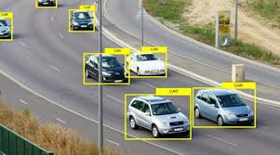
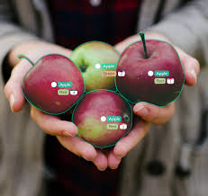

Conclusion:-
In conclusion, the choice between bounding boxes and polygons for image annotation hinges on the balance between efficiency and precision. Bounding boxes offer a swift and straightforward annotation process, making them ideal for tasks where speed is paramount, such as large-scale object detection projects. However, their simplicity comes at the cost of potentially sacrificing precision, especially when dealing with irregularly shaped objects or nuanced segmentation requirements.
On the other hand, polygons provide a more detailed and accurate delineation of object boundaries, making them well-suited for tasks that demand fine-grained segmentation, such as medical imaging or satellite imagery analysis. While polygons offer superior precision, they require more time and expertise to annotate accurately, which can be a limiting factor for large datasets or projects with tight timelines.
Here , we are going for polygon tool..

Data Augmentation:-
